DATA MODELLING AND TRANSFORMATION IN POWER BI

Week 2 Internship Task
Project: Sales Performance Analysis Dashboard using Microsoft Power BI

Submitted by: SONU KUMAR SHAW
Internship: Virtual Power BI Data Visualization Intern
STREAM: BBA
COLLAGE: B.P.Poddar Institute of Management and Technology

Week 2 Task

- Introduction

Data modelling is an important part of a Power BI project because it organizes raw data into a logical structure that supports accurate analysis and clear visualizations. A good data model makes reports easier to understand, improves calculation accuracy and helps users explore information efficiently.

This Week 2 document presents the planned data transformation and modelling approach for the Sales Performance Analysis Dashboard introduced in Week 1. The project uses the Microsoft Financial Sample dataset as a publicly available reference. The aim is to explain how raw data can be cleaned, transformed, organized into related tables and prepared for Power BI reporting.

- Importance of Data Modelling in Power BI

In Power BI, a data model connects different tables and a lows them to work together for analysis. Instead of keeping a l information in one large structure, related information can be organized into logical tables. Relationships between tables make it possible to filter, summarize and calculate data correctly. A well-designed data model supports:

• Accurate calculations and measures.
• Faster and more organized reporting.
• Easier filtering and drill-down analysis.
• Clear relationships between business entities.
• Better performance and easier maintenance.
• Moreunderstandable dashboards and visualizations.

- Planned Data Source and Acquisition Method

The planned data source is the Microsoft Financial Sample dataset, a publicly available sample dataset used for Power BI learning and demonstration. The dataset contains financial and sales-related information such as date, country, product, segment, sales, profit, units sold, manufacturing price and discounts. Data acquisition method:

- Download the Financial Sample dataset from the official Microsoft Power BI learning source.
- Open Power BI Desktop.
- Select Get Data and choose Excel or the appropriate file type.
- Select the required worksheet or table.
- Load the data into Power Query for cleaning and transformation.
- Load the prepared tables into the Power BI data model.

- Data Source Analysis

The source data will be reviewed before modelling. Important checks will include:
• Understanding the meaning of every column.
• Checking data types such as Date, Text, Whole Number and Decimal Number.
• Identifying missing or blank values.
• Checking for duplicate records.
• Reviewing inconsistent text values.
• Identifying fields needed for relationships and calculations.

The main planned business entities are Date, Product, Country, Segment and Financial/Sales data.

- Data Cleaning Strategy

The data cleaning process will be performed mainly through Power Query. The planned steps are:
- Remove unnecessary columns.
- Check and correct data types.
- Remove invalid duplicate records.
- Identify and handle blank or missing values.
- Trim extra spaces from text fields.
- Standardize inconsistent names or categories.
- Check numerical fields for invalid values.
- Rename columns clearly.
- Validate the cleaned data before loading it into the final model.

- Data Transformation and Integration Plan

After cleaning, the data will be transformed into a structure suitable for analysis. A flat source table can be logically separated into a central fact table and supporting dimension tables.
• Fact Financials: Sales, Profit, COGS, Units Sold and Discounts.
• Dim Date: Date , Month and Year.
• Dim Product: Product and Product Category.
• Dim Country: Country.
• Dim Segment: Segment.

Suitable keys will connect the dimension tables to the facts table. This structure reduces repetition and creates a clearer model for reporting.

- Proposed Logical Data Model

The proposed model follows a star-schema approach. Fact Financials will be the central table because it contains the main numerical values used for analysis. The surrounding dimension tables will provide descriptive information for filtering and grouping the data.

The planned relationships are primarily one-to-many, where one value in a dimension table can be related to many records in the fact table.

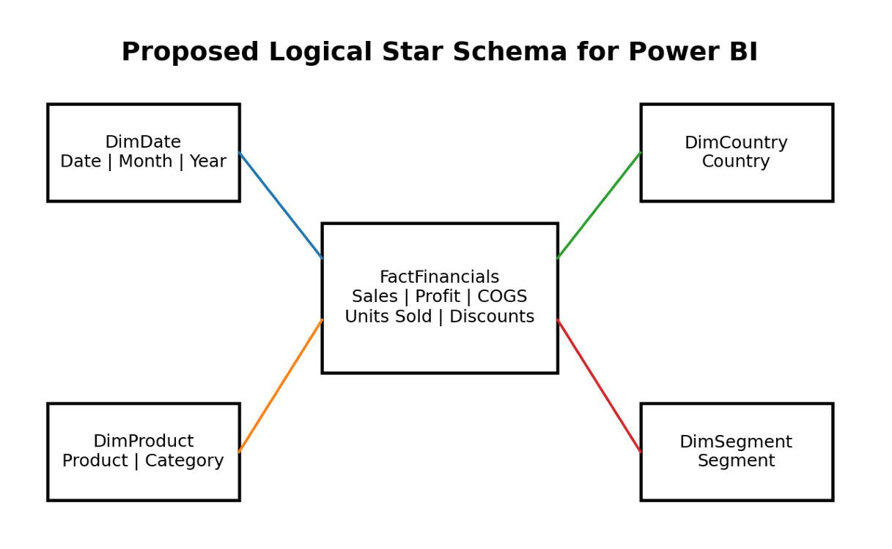
Figure 1: Proposed logical star-schema data model for the Sales Performance Analysis project.
8. Data Entities and Their Roles
Entity/Table | Purpose | Example Fields
DimDate | Supports time-based filtering and trend analysis. | Date, Month, Year
DimProduct | Provides product information for comparison. | Product, Product Category
DimCountry | Supports geographical analysis. | Country
DimSegment | Supports analysis by business segment. | Segment
FactFinancials | Stores the main measurable financial values. | Sales, Profit, COGS, Units Sold, Discounts

- Normalization Approach

Normalization helps reduce unnecessary repetition and organizes information into logical groups. Descriptive information such as product, country and segment will be separated from the main numerical financial records. This makes the structure easier to maintain and understand.
For the planned Power BI model, a simple star schema is preferred because it is easier for business reporting and supports clear relationships between dimensions and facts.

- Relationship Design

The proposed relationships will connect each dimension table to the central Fact Financials table:
• DimDate (1) →FactFinancials (Many)
• DimProduct (1) →FactFinancials (Many)
• DimCountry(1) →FactFinancials (Many)
• DimSegment(1) → FactFinancials (Many)

The relationships will be checked carefully to avoid ambiguous paths, duplicate filtering and incorrect calculations. Single-direction filtering from dimension tables to the fact table will be preferred unless another approach is necessary.

- Planned Measures and Calculations

After the model is prepared, Power BI measures can support analysis:
• Total Sales = Sum of Sales.
• Total Profit = Sum of Profit.
• Total Units Sold = Sum of Units Sold.
• Total COGS = Sum of Cost of Goods Sold.
• Profit Margin = Total Profit divided by Total Sales, where appropriate.

These measures will be validated before they are used in final visualizations.
- Impact on Visualization Performance and Clarity

A well-structured data model will improve both performance and clarity. Dimension tables will provide clean fields for slicers and chart categories, while the fact table will provide numerical values for KPIs and calculations.

The model will help answer questions such as:
• How are sales and profit changing over time?
• Which country performs best?
• Which products or categories have stronger results?
• How does performance differ by segment?

A clear model also reduces confusion when building visuals and helps ensure that filters and calculations work correctly.

- Data Quality and Validation Plan

Before using the model for reporting, the following checks wilbe performed:
• Confirm correct data types.
• Check unexpected blank values.
• Verify key fields are consistent.
• Confirm relationships work correctly.
• Compare important totals with source data.
• Test filters and slicers.
• Check calculations for accuracy.
• Review unnecessary columns and relationships.

- Expected Outcome

The expected outcome is a clean and logical Power BI data model that provides a strong foundation for later dashboard development. The model will organize financial and sales information into meaningful entities, define clear relationships and support accurate measures and visualizations.

- Conclusion

Week 2 focuses on the backbone of the Power BI visualization project: data modelling and transformation. The planned approach begins with understanding the public data source and checking data quality. The data is then cleaned, transformed and logically organized into dimension tables and a central fact table. The proposed star-schema model will support clear relationships, reliable calculations and effective visualizations. Overall, this document provides a structured plan for preparing the data before moving to advanced dashboard and reporting tasks.

